LKMY - Let’s Rock n’ Roll into the Future!
A new rock band with soul and inspiring lyrics, formed with members from Ramtha’s School of Enlightenment

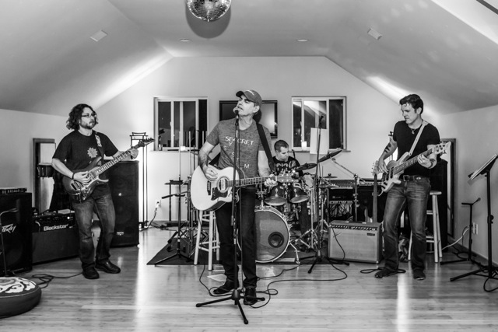

I will never forget when I first met David Fairley close to Ramtha’s stage during an event with Ramtha teaching about the great revolution of the ‘60s and the immortal free Spirits and troubadours of that era, the great heroes of our modern times. Ramtha was moving to the rhythm of Kansas classic song, “Carry on Wayward Son,” like only a God can do. He was amazing, as always, and Dave and I were rocking to the moment close to the side of the stage. Dave was mimicking drumming moves and I was pretending to play my invisible electric guitar, following Ramtha’s lead on the stage. We stopped for a moment and looked at each other and asked the same question, almost at the same time, “Do you play music?” We both started laughing when we said, “Yes! Let’s get together and play.” That was more than a decade ago. Alan Dugan joined us back then, bringing his great talent and voice and many of his original songs he wrote. He is a prolific writer with great soul, a survivor who healed from cancer, and a very talented musician and great human being. Scotty Jones joined us pretty early too with his great jazzy-reggae and rock tones on his bass. Scotty is a very talented, happy being in love with life. We love rocking out and creating music with soul and a message.
Dave came up with the name LKMY, which is like a riddle that best describes what the band and our music means to us. If you say it fast enough, you may catch what it really stands for.
We have our first live performance in Yelm on June 6, 2015, at the well-known Triad Theater with our original music, which we are already in the process of recording professionally, thanks to the brilliant genius of LKMY Sound Engineer, Scott Lisonbee. We want to invite the whole RSE community to come and enjoy a great evening of music and rock with a soul.
You can find more details about LKMY and our upcoming show on our Facebook page here:
https://www.facebook.com/LKMYband
Come join us rock n’ roll into the future!
Jaime Leal-Anaya

