Press Release - Alberta Surface Rights Group
January 4, 2012
Hydraulic Fracturing: Alberta’s Water in Peril

There is an immediate need for honest, full disclosure on the energy industry’s hazardous process known as hydraulic fracturing (fracking). The Alberta Surface Rights Group is launching an initiative to inform and warn Albertans.

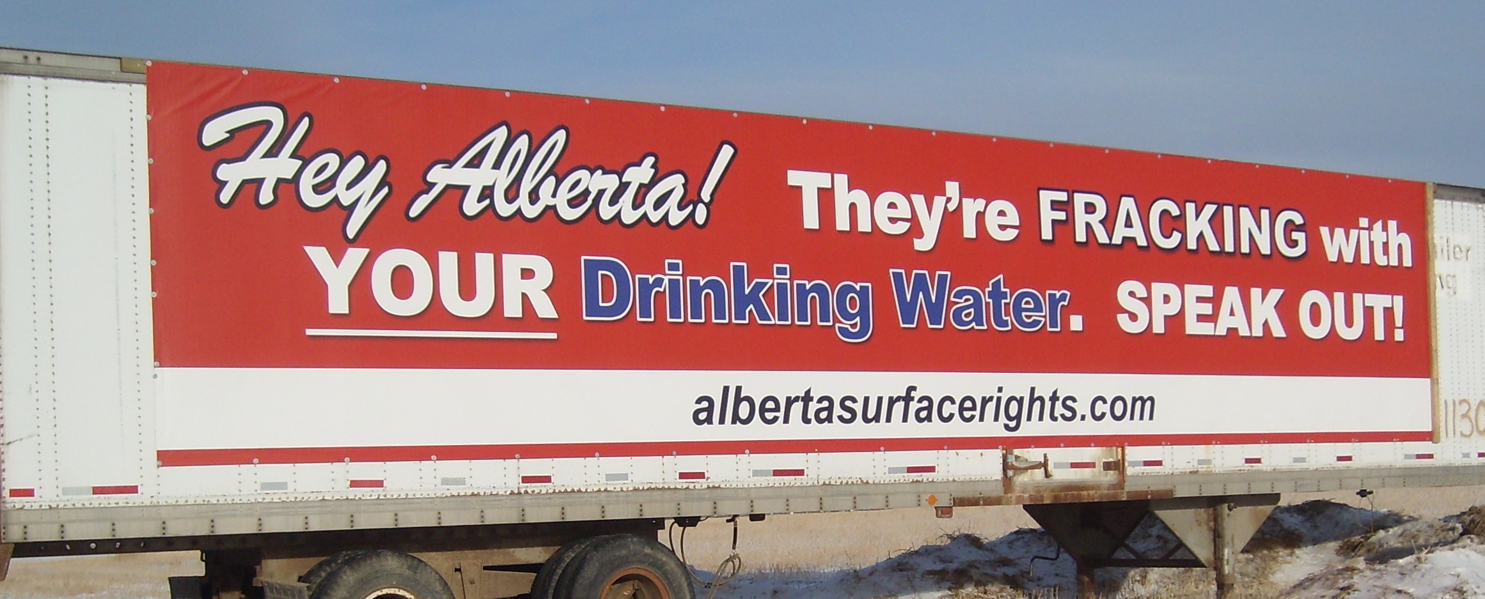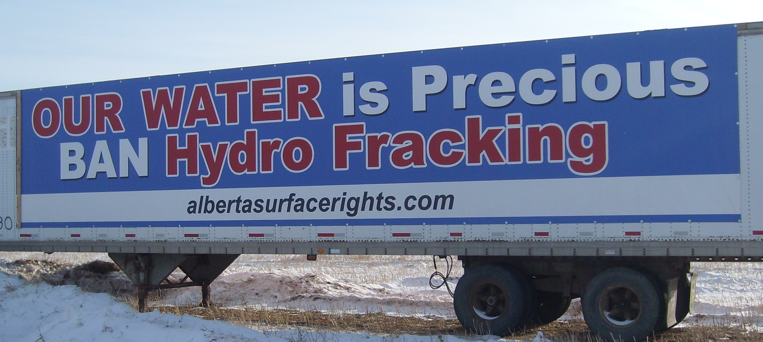
Banners on an ASRG trailer located 2 miles south of Trochu on Hwy. 21
Photos by ASRG

Fracking is a brute force procedure that transmits extreme pressure underground using large volumes of fluids, undisclosed chemicals, and sand to fracture and open up cracks in shales, sands, and coals that are underlying much of Alberta and many locations around the world.

Why our concerns? There are many, but they center around an unchallenged assault on our environment, with many associated risks and long term consequences.

Important facts everyone needs to know:

Fracking:

1) Requires huge volumes of fresh water (your drinking water); millions of gallons are used per well, depending on the targeted formation.

2) Contaminates the water used and must be disposed of. Poisoned water underground remains a long term issue.

3) Removes large volumes from the water cycle – perhaps forever.

4) Potentially connects man-made fractures with natural fractures that can contaminate or drain groundwater.

5) Increases heavy traffic. Roads are damaged; noise, dust, air, and light pollution accompany the damages.

6) Creates earthquakes.

We don’t need “experts” to verify that hydraulic fracturing unconventional tight oil and gas creates problems.

More information at: albertasurfacerights.com

Contact:

Kevin Niemi 403-442-4238
kevin_niemi@hotmail.com

